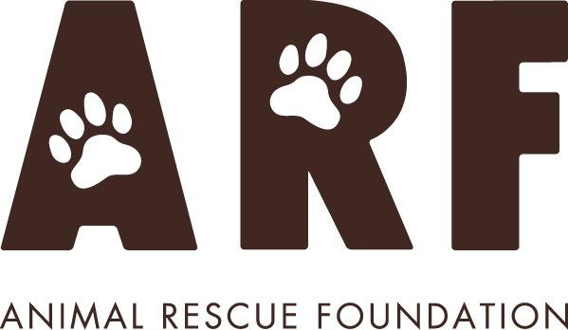

**Nomination Form**

**Candidate for the Board of Directors**

**Annual General Meeting December 5, 2024**

Name of Nominee:

ARF Membership #:

Occupation:

Identify your skills and abilities:

|  |
| --- |
|  |

Outline your volunteer work for/with ARF in the last year:

|  |
| --- |
|  |

Outline your past/present volunteer experience with other organizations:

|  |
| --- |
|  |

Describe what skills/expertise you would contribute to ARF as a member of the Board of Directors:

|  |
| --- |
|  |

Indicate the number of hours per month you are willing to commit to ARF:

|  |
| --- |
|  |

As a member of the Board of Directors you are required to attend meetings and some events. How flexible is your schedule and what conflicts would you have with your other commitments?

|  |
| --- |
|  |

Nominee Name: ________________________________ Signature: _____________________________

Date: ____________________, 2024

Signatures of two sponsoring members in good standing:

Name: ____________________________ Signature: _____________________ Member #: __________

Name: ____________________________ Signature: _____________________ Member #: __________

Please submit this form by email to [general.info@arf.ab.ca](mailto:general.info@arf.ab.ca) or by mail as provided below. Nomination form must be received no later than midnight on November 20, 2024. **The contents of this nomination form will be posted on** [arf.ab.ca](http://www.arf.ab.ca) until the AGM date of December 5, 2024.